Using ROS Parameters

See:

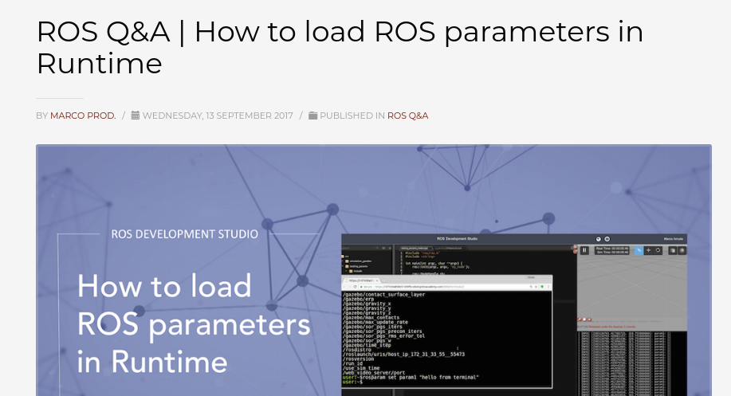
https://www.theconstructsim.com/load-ros-parameters-runtime/?utm_source=youtube&utm_medium=ros_qa&utm_campaign=38

rosparam get /roslaunch/uris/host_tractor_aj__33987

ubuntu@ubiquityrobot:~$ rosparam list
/rosdistro
/roslaunch/uris/host_tractor_aj__33987
/rosversion
/run_id
ubuntu@ubiquityrobot:~$

1-800-444-6742
Model # ct52vp5lkrc

https://roboticsbackend.com/get-set-ros-params-rospy-roscpp/

$ rosparam set my_integer 7
$ rosparam get /my_integer

<launch>
<param name="my_integer" type="int" value="7" />
</launch>

For C++
int int_var;
ros::param::get("/my_integer", int_var);
ROS_INFO("Int: %d, int_var);
Launch file:
<param name="steering_max_power" type="int" value="51" />

C++
ros::param::get("/steering_max_power", max_steer_eff);

Test:
$ rosparam set /pid "[1.0, 2.0, 3.0]"
rosparam get /pid

Trying
$ rosrun rosserial_python serial_node.py /dev/steer_motor

Can't pass in a numerical string as arg param to C++ node

https://github.com/ros/ros_comm/issues/1339

Uses, nh.getParam("str_param", test);

$ rosparam list /pid
$ rosparam get /steering

$ rosparam list /move_base_flex/TebLocalPlannerROS/max_vel_x

$ rosparam get /move_base_flex/TebLocalPlannerROS/max_vel_x

al@al-ThinkPad-W530:~$ rosparam get /move_base_flex/TebLocalPlannerROS/max_vel_x
2.0
al@al-ThinkPad-W530:~$

$ rosparam set /move_base_flex/TebLocalPlannerROS/max_vel_x 0.75
$ rosparam get /move_base_flex/TebLocalPlannerROS/max_vel_theta
$ rosparam get /move_base_flex/TebLocalPlannerROS/max_vel_x

$ nano teb_local_planner_params_carlike.yaml
$ vim teb_local_planner_params_carlike.yaml

In roslaunch teensy_launch.launch I used
<rosparam param="steering">[-14000.0, 13500.0, 0.0, 60.0, 3.0]</rosparam>
<rosparam param="speed">[1000.0, 1290.0, 1600.0, 135.0, -100.0, 70.0, 5.0, 0.0, 20.0]</rosparam>

To set the parameter from the command line:
$ rosparam set /steering "[27900.0, 45798.0, 36874.0, 50.0, 2.0]"
<launch>
<param name="my_float" type="double" value="3.14" />
<node name="node_name" pkg="your_package" type="test_params.py" output="screen"/>
</launch>

$ rosparam set my_float 3.14
float_var = rospy.get_param("/my_float")

_GPS_origin_lat = 40.345245345
_GPS_origin_lon = -80.128990477

$ rosparam set origin_lat 40.345245345
$ rosparam set origin_lon -80.128990477

see test_read_ros_param.py which reads .txt file, set’s two parameters, then reads them back and prints the results.

